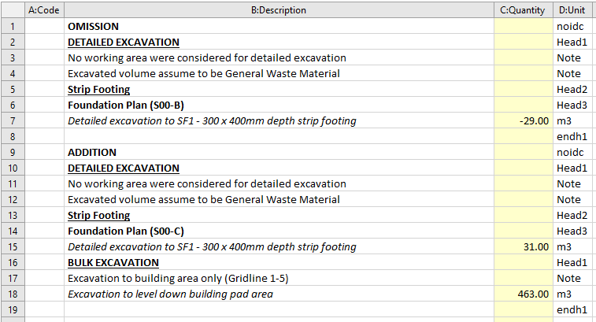
ADDENDUM FORMAT
NOTE:
- List down all the items form the original Masterfile with addendum under OMISSION and make it negative.
- Incorporate necessary adjustments/additions to every item with addendum and place it under ADDITION.
(See attached sample photo above for reference)

